**Unit 4 - Reading 2**

**Force Diagrams and System Schema**

A proper force diagram will include the following elements:

* A system schema that shows the object(s) that make up the system being analyzed.
* A dotted line around the object(s), which denotes the elements of the system.
* Each connection on the system schema becomes an arrow on the force diagram.
* An arrow of appropriate length, in the proper direction to represent each force.
* An appropriate label for each force.
* All force arrows should start at the center of the object.

Changes

in Velocity

Forces

infer

deduce

Changes in Velocity

Deduce

Infer

Forces

Force Diagrams can depict situations where the forces are *balanced* and situations where the forces are *unbalanced*. In this section we will explore the relationship between motion and these force situations that are responsible for them.

In other words, by identifying the type of motion we are dealing with, we can determine whether the forces are balanced or unbalanced. Or, in reverse, if we know the forces are balanced or unbalanced, we can determine the type of motion.

There are five major motion situations that we will deal with in this unit. These include:

1. Objects at rest (balanced forces).
2. Objects moving at a constant speed in a straight line (balanced forces).
3. Objects that are speeding up (unbalanced forces).
4. Objects that are slowing down (unbalanced forces).
5. Objects that are changing direction (unbalanced forces).

**Situations 1 & 2: Objects at rest and objects undergoing uniform motion**

Objects at rest and objects undergoing uniform motion are both examples of objects that experience no unbalanced force. In other words, the forces acting on an object must be balanced for an object to be at rest or for one to move at a constant speed in a straight line (aka, constant velocity).

**Balanced Force Diagrams**

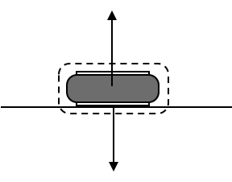A hover puck sits perfectly still on a perfectly level surface with the fan turned off. The earth pulls downward on it with a gravitational force. We denote this force as ${\vec{F}}_{g by E on p}$. The puck doesn’t fall as a result of this force, so there must be a force balancing the gravitational force. That force is from the table pushing upward on the puck. We denote the upward push on the puck by the table ${\vec{F}}_{N by t on p}$.

$${\vec{F}}_{N by t on p}$$

$${\vec{F}}_{g by E on p}$$

The pictorial diagram for this situation must show the puck and the floor. Superimposed on the pictorial diagram, is the force diagram. The two forces acting on the object are the same magnitude, but act in opposite directions, so they are balanced. Mathematically, this means that their sum is zero. Therefore, the unbalanced force (or ‘net force’) acting on the puck is zero.

*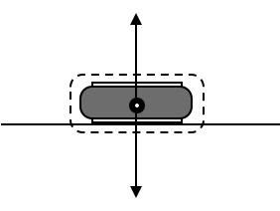What happens to the force diagram if the fan is now turned to the on position?* If the surface on which the puck is placed is truly level, the puck will hover motionless on a cushion of air. The gravitational force, ${\vec{F}}_{g by E on p}$, will not change. The air instead of the table now provides the upward force. This new force, the upward push on the puck by the air is denoted ${\vec{F}}_{A by a on p}$.

$${\vec{F}}_{g by E on p}$$

$${\vec{F}}_{A by a on p}$$

The force diagram looks exactly the same as before, except for the label on the upward force. The unbalanced force on the puck is zero, just as it was when the puck was resting on the table with the fan turned off.

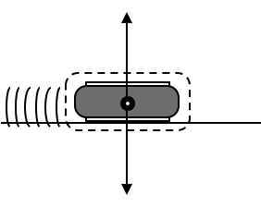Let us now assume that the puck is already moving to the right (How it started moving is outside our observation window, so we cannot concern ourselves with that). What forces act on the puck now? Interestingly, the force diagram is identical to the previous situation. The puck experiences only the downward force of gravity due to the earth ${\vec{F}}_{g by E on p}$, and the upward force on the puck by the air ${\vec{F}}_{A by a on p}$. The forces remain balanced. And so, mathematically the unbalanced force (net force) on the puck is still zero.

$${\vec{F}}_{g by E on p}$$

$${\vec{F}}_{A by a on p}$$

The most important thing to understand about this situation is that the puck will, as long as the forces remain balanced, travel at the same speed in a straight line. Nothing is required to cause the puck to keep moving. An unbalanced force would be required to cause it to go faster or slower, and/or an unbalanced force would be necessary to change its direction. But in the absence of an unbalanced force, the puck will continue to move in a straight line at a constant speed.

This fact of nature, that objects will maintain their state of motion or rest, as long as there is no unbalanced force on them, is sometimes called Newton’s 1st Law of Motion. (Some would say that the objects maintain their motion, or lack thereof, because of inertia. This is a very dangerous way to think. This would attribute a cause to the motion or rest state, which inevitably leads students to think of inertia as somehow being “force like.”) The most reasonable definition of inertia might be that it is a measure of an object’s resistance to changing its motion. The more massive something is, the harder it is to change its motion. Therefore, an object’s inertia has to do with how much mass it has and is sometimes used as the definition for mass. It has nothing to do with a force. Inertia is not a cause of anything, and we don’t want you to think it is. It would be far better not to use the term than to misuse it.

**Force Diagrams when the Unbalanced Force is Non-Zero: Speeding Up**

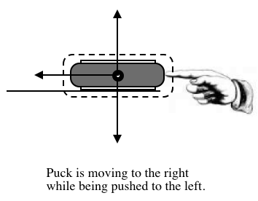Consider a hover puck, with the fan turned on, which is at rest on a level surface but has a person pushing it to the right. The downward force of gravity on the puck, ${\vec{F}}_{g by E on p}$, and the upward push of the air on the puck, ${\vec{F}}_{A by a on p}$, still act on the puck. Additionally, the person is exerting a force (by pushing with their hand) on the puck to the right. Let’s call that force ${\vec{F}}_{A by h on p}$. Since the first two forces, ${\vec{F}}_{g by E on p}$ and ${\vec{F}}_{A by a on p}$, are *balanced*, the remaining force, ${\vec{F}}_{A by h on p}$, is the *unbalanced* force. The result of this *unbalanced* force, or any *unbalanced* force for that matter, is that the object in question will accelerate. This is to say that the object will speed up, slow down, or change directions. In this case, the *unbalanced* force will cause the object to begin to move in the direction of the force. After it starts moving, the *unbalanced* force acts in the same direction as the object is moving and the result is that the object will speed up. Anytime the *unbalanced* force on an object acts in the same direction the object is traveling, the object will speed up in the direction of the net force.

$${\vec{F}}_{A by a on p}$$

$${\vec{F}}_{A by h on p}$$

$${\vec{F}}_{g by E on p}$$

If we were to make a movie of the puck from overhead while the puck was being pushed, the frames of the movie would look something like this (minus the arrows).



The arrows above the images of the puck are intended to convey the changing speed of the puck. In this case the length of the arrows represents the speed of the puck and the direction the arrows point represents the direction the puck is moving. The big idea here is simple: Whenever an object experiences an unbalanced force in the same direction it is moving, it will speed up!

**Force Diagrams when the Unbalanced Force is Non-Zero: Slowing Down**

Now let’s consider a different situation. In this case, the puck (fan turned on) is already moving to the right. A person pushes the puck to the left, while it is moving toward her. Remember, the puck is moving to the right while being pushed to the left. How will this affect the motion of the puck. Analysis of the force diagram indicates that the *unbalanced* force is ${\vec{F}}_{A by h on p}$. In this case, and any time the direction of the *unbalanced* force is opposite the direction of motion, the object will slow down. The video analysis of the puck would look something like this:



$${\vec{F}}_{A by h on p}$$

$${\vec{F}}_{A by a on p}$$

$${\vec{F}}_{g by E on p}$$

Notice that the images of the puck are getting closer together, indicating that the puck is slowing down. The arrows, indicating velocity, are getting shorter as well.

***Big idea: Whenever an object experiences an unbalanced force opposite the direction it is moving, it will slow down!***